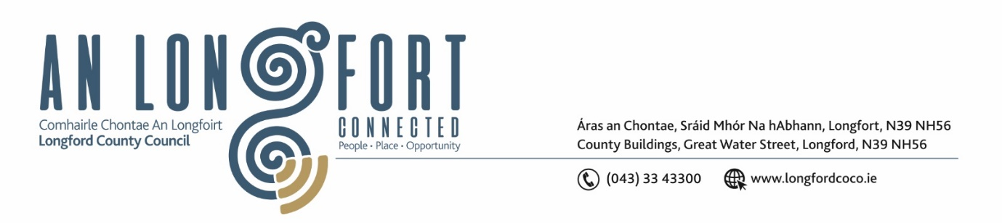

***Please note meeting will be held in the Council Chamber and via Microsoft Teams.***

7ú Deireadh Fómhair 2021.

**Chuig: Gach Ball don Chomhairle.**

A Chomhairleoir,

Iarrtar ort bheith i láthair ag Cruinniú Míosuil Chomhairle Chontae Longfoirt a tionólfar i Seomra na Comhairle, Aras an Chontae, Longford agus via MS Teams are an **Chéadaoin, 13ú Deireadh Fómhair 2021 ag** **3.00pm** chun gnó a dhéanamh d’réir an Chláir thíos.

You are requested to attend the Monthly Meeting of Longford County Council to be held **in the Council Chamber, Aras an Chontae and** **via Microsoft Teams** on **Wednesday, 13th October 2021 at 3.00pm** to transact business, as set out on the Agenda hereunder.

Mise le meas,

*Ann Marie Mc Keon*

**__________________**

**Ann Marie Mc Keon**

**Meetings Administrator.**

**C L Á R**

Prayer before meeting.

**Deputation from Longford Women’s Link - Notice of Motion Councillor Uruemu Adejinmi**

I am asking Longford County Council to call on the Minister for Justice to consider introducing a specific offence of stalking on to the statute books as well as longer sentences for the crime than that currently available to prosecutors.

1. Confirmation of Minutes of Monthly Meeting of Longford County Council held on

8th September 2021 – copy enclosed.

1. Matters Arising.
2. Declaration of Interest by Members.
3. To note Management Report – enclosed.

**5.** To note adopted Minutes of Corporate Policy Group Meeting held on the

13th July 2021 - enclosed.

**6. Community, Corporate and Enterprise**

(a) Consideration of agreement between Granard Town Twinning and East Rouen, Normandy.

(b) Proposal by Cathaoirleach Peggy Nolan to confer the Freedom of the County.

(c) Consideration of amendments to Longford County Council Standing Orders and

Supplementary Standing Orders – enclosed.

(d) Consideration to approve grant under the 2021 Intercultural Grants Scheme – enclosed.

**7. Finance**

(a) Consideration of the disposal of property at 22 Annaly Park, Longford, County Longford (under the shared ownership scheme), in accordance with the terms of Section 183 of the Local Government Act 2001 issued on the 9th September 2021.

(b) Consideration of the disposal of property at 29 Teffia Park, Longford, County Longford (under the shared ownership scheme), in accordance with the terms of Section 183 of the Local Government Act 2001 issued on the 9th September 2021.

(c)  **DATES FOR BUDGET MEETINGS:**

Granard MD – General Municipal Allocation Meeting – Tuesday 26th October.

Longford MD – General Municipal Allocation Meeting – Wednesday 27th October.

Ballymahon MD – General Municipal Allocation Meeting – Thursday 28th October.

Budget 2022 – ‘In Committee’ Meeting – Monday 15th November.

Budget 2022 Meeting – Monday 22nd November

(d) Notices of Motions, submitted by Councillors, as listed hereunder –

**Councillor Paul Ross**

I call on the Minister for the Environment, Climate and communications to immediately accelerate the National Broadband Ireland (NBI) plan for the rollout of Broadband in County Longford as according to the NBI website the majority of County Longford will not see broadband until 2026.

**8. Strategic Infrastructure, Regeneration and Climate Change**

(a) To note Planning Applications received since last meeting of the Council.

(b) Consideration of the disposal of rural detached bungalow at Cornafunshion, Ballinalee, County Longford in accordance with the terms of Section 183 of the Local Government Act 2001 issued on the 22nd September 2021.

(c) Consideration of the disposal of a strip of land at Lamagh, Newtownforbes, County Longford in accordance with the terms of Section 183 of the Local Government Act 2001 issued on the 22nd September 2021.

(d) Consideration of the disposal of a strip of land at Lamagh, Newtownforbes, County Longford in accordance with the terms of Section 183 of the Local Government Act 2001 issued on the 22nd September 2021.

(e) Consideration of the disposal of rural detached bungalow at Castlenugent, Granard, County Longford in accordance with the terms of Section 183 of the Local Government Act 2001 issued on the 29th September 2021.

(f) Notices of Motions, submitted by Councillors, as listed hereunder –

**Councillor Uruemu Adejinmi**

I call on Longford County Council to write to the Department of Housing and Local Government to request allocation for a dedicated dereliction officer in County Longford. This officer will engage with owners of derelict and unoccupied residential and commercial properties to reduce the number of derelict properties in our towns and villages and have vacant spaces occupied by businesses and families. The Dereliction Officer will also liaise with planning and regeneration teams and provide relevant information to support their work.

**Councillor Paul Ross**

I call on Longford County Council to write to the Minister for Environment, Climate and Communications and the Minister for Housing, Local Government and Heritage to provide a “fast-track ‘one-stop-shop’ framework for planning and licensing” for the harvesting of horticultural peat, as was recommended by The Just Transition Commissioner in his progress report dated April 2020.  Such a ‘streamlined approach between Statutory Bodies’ would help prevent the absurdity of 200 truckloads of peat being imported from Latvia to be stockpiled on a bog just outside Legan and would instead allow the resumption of the responsible harvesting of peat moss here in Ireland, as it occurs elsewhere in Europe, in Northern Ireland, Scotland, England, Sweden, Denmark, Germany, Finland, Estonia, Latvia, and Lithuania.”

**Councillor Gerry Warnock**

I am calling on Longford County Council to reach out to the eleven other local authorities who find themselves discriminated against by restrictive criteria published by the Department of Housing, Planning & Local Government, that in effect precludes twelve local authorities from advancing New Build Affordable Housing within their respective jurisdiction’s. A New Build Affordable Housing option in Longford is crucial in assisting households on moderate incomes who wish access to home ownership and every local authority should have the capability to enable eligible households to achieve this goal.

**9. Correspondence**

**(i)** Correspondence dated 6th September 2021 received from the Department of

Tourism, Culture, Arts, Gaeltacht, Sport and Media - Reply to Notice of

Motion submitted by Councillor Martin Monaghan – enclosed.

**(ii)** Correspondence dated 21st September 2021 from the Minister of Health

– Reply to Notice of Motion submitted by Councillor Uruemu Adejinmi –

enclosed.

**10. Votes of Sympathy**